1-Letter

🔠 What is a Letter?
# Source: Chatgpt (GPT-4-turbo) at [7/22/2025]
A letter is a symbol or character used in a writing system to represent one or more sounds (usually phonemes) in a language.

📘 Definition:
# Source: Chatgpt (GPT-4-turbo) at [7/22/2025]
A letter is a written or printed character that represents a phoneme in an alphabetic writing system.

✍️ Examples:
# Source: Chatgpt (GPT-4-turbo) at [7/22/2025]
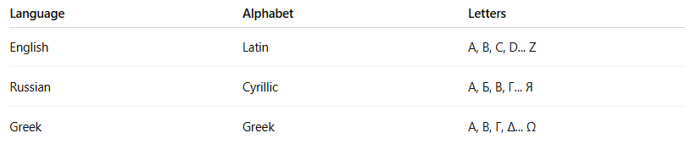
Language | Alphabet | Letters
English | Latin | A, B, C, D... Z
Russian | Cyrillic | А, Б, В, Г... Я
Greek | Greek | Α, Β, Γ, Δ... Ω

🧠 Key Points:
# Source: Chatgpt (GPT-4-turbo) at [7/22/2025]
- Letters are graphemes: The smallest units in writing that carry meaning.
- In alphabetic systems, each letter usually represents one sound (or a combination of sounds).
- Letters can appear in uppercase (A, B, C) and lowercase (a, b, c).
- Some letters can represent different sounds depending on the context (e.g., English "c" in cat vs. cereal).

💡 Letter vs. Sound (Phoneme):
# Source: Chatgpt (GPT-4-turbo) at [7/22/2025]
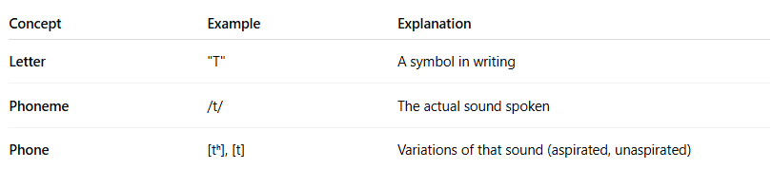
Concept | Example | Explanation
Letter | "T" | A symbol in writing
Phoneme | /t/ | The actual sound spoken
Phone | [tʰ], [t] | Variations of that sound (aspirated, unaspirated)

✅ Summary:
# Source: Chatgpt (GPT-4-turbo) at [7/22/2025]
A letter is a visual symbol used in a writing system to represent the sounds of a language. In alphabetic systems, letters are the building blocks of written words.

2-Word

🧩 What is a Word?
# Source: Chatgpt (GPT-4-turbo) at [7/22/2025]
A word is the smallest independent unit of meaning in a language that can stand alone and perform a grammatical function (like being a noun, verb, adjective, etc.).

📘 Definition:
# Source: Chatgpt (GPT-4-turbo) at [7/22/2025]
A word is a meaningful unit of language that is made up of one or more morphemes, and can stand alone in speech or writing.

🔍 Examples:
# Source: Chatgpt (GPT-4-turbo) at [7/22/2025]
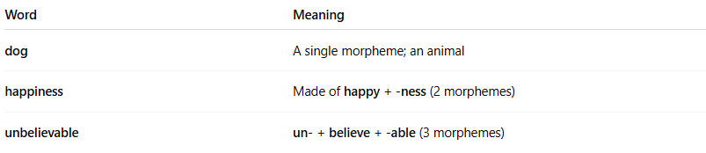
Word | Meaning
dog | A single morpheme; an animal
happiness | Made of happy + -ness (2 morphemes)
unbelievable | un- + believe + -able (3 morphemes)

🧠 Key Features of a Word:
# Source: Chatgpt (GPT-4-turbo) at [7/22/2025]
- Has meaning
- Can stand alone
- Can be spoken or written
- Follows grammar rules of the language
- Made of letters (in alphabetic writing systems)

🧪 Word vs. Morpheme:
# Source: Chatgpt (GPT-4-turbo) at [7/22/2025]
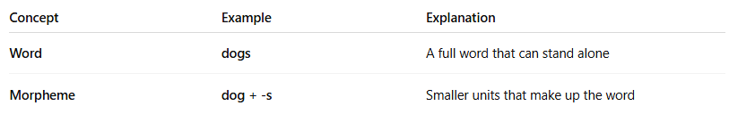
Concept | Example | Explanation
Word | dogs | A full word that can stand alone
Morpheme | dog + -s | Smaller units that make up the word
✅ All words contain at least one morpheme, but not all morphemes are words (example: -s can't stand alone).

🧠 Types of Words:
# Source: Chatgpt (GPT-4-turbo) at [7/22/2025]
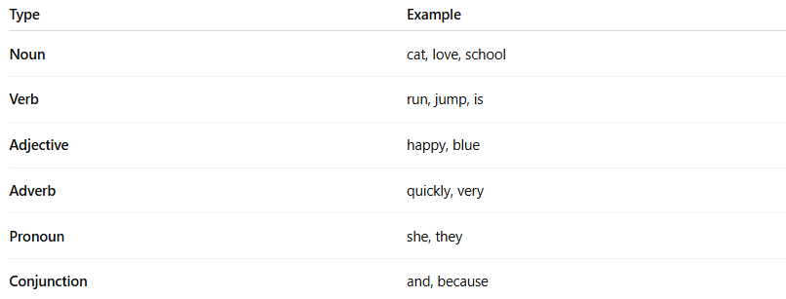
Type | Example
Noun | cat, love, school
Verb | run, jump, is
Adjective | happy, blue
Adverb | quickly, very
Pronoun | she, they
Conjunction | and, because

✅ Summary:
# Source: Chatgpt (GPT-4-turbo) at [7/22/2025]
A word is a unit of language made of one or more morphemes, that has meaning and can function independently in speech or writing.

3-Sentence

✏️ What is a Sentence?
# Source: Chatgpt (GPT-4-turbo) at [7/22/2025]
A sentence is a group of words that expresses a complete thought. It usually contains at least a subject and a predicate (which includes a verb), and it starts with a capital letter and ends with a period (.), question mark (?), or exclamation point (!).

📘 Definition:
# Source: Chatgpt (GPT-4-turbo) at [7/22/2025]
A sentence is the smallest complete unit of grammar that expresses a statement, question, command, or exclamation.

🧠 Key Features of a Sentence:
# Source: Chatgpt (GPT-4-turbo) at [7/22/2025]
- Subject: Who or what the sentence is about
- Predicate: What the subject does or is
- Complete meaning: It can stand alone and make sense
- Punctuation: Ends with ., ?, or !

🧾 Examples:
# Source: Chatgpt (GPT-4-turbo) at [7/22/2025]
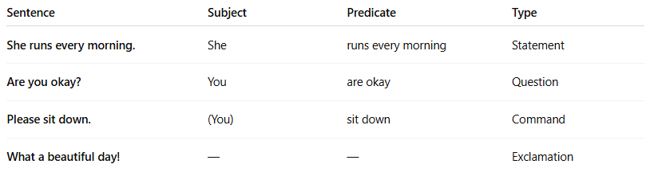

Sentence | Subject | Predicate | Type
She runs every morning. | She | runs every morning | Statement
Are you okay? | You | are okay | Question
Please sit down. | (You) | sit down | Command
What a beautiful day! | — | — | Exclamation

🧩 Types of Sentences:
# Source: Chatgpt (GPT-4-turbo) at [7/22/2025]
- Declarative – Makes a statement
→ I like coffee.
- Interrogative – Asks a question
→ Do you like tea?
- Imperative – Gives a command
→ Close the door.
- Exclamatory – Expresses strong feeling
→ That’s amazing!

✅ Summary:
# Source: Chatgpt (GPT-4-turbo) at [7/22/2025]
A sentence is a group of words that forms a complete thought, usually with a subject and a verb, and proper punctuation.

